|  |
| --- |
| My Portfolio |
| Faculty of Contemporary Sciences and Technologies |
| *Student: Mentor: Drin Kurtishi PhD. Prof. Ermira Idrizi* |



Contents

Tetovo, June 2023

# Table of Contents

1. Role of the Website on the Internet…………………………………………………………………………………………………2

2. Website Content………………………………………………………………………………………………………………………………2

2.1 Lock Screen………………………………………………………………………………………………………………………..2

2.2 About Me……………………………………………………………………………………………………………………………2

2.3 Projects………………………………………………………………………………………………………………………………2

2.4 Contact Me…………………………………………………………………………………………………………………………2

3. Website Content Strategy……………………………………………………………………………………………….…………………2

4. Defining and Implementing the Idea……………………………………………………………………………………….…………2

5. Template Design………………………………………………………………………………………………………………………………..3

6. Website Diagram……………………………………………………………………………………………………………………………….3

7. Tools and Platforms……………………………………………………………………………………………………………………………4

8. Implementation………………………………………………………………………………………………………………………………….4

8.1 HTML Structure……………………………………………………………………………………………………………………4

8.2 CSS Styling…………………………………………………………………………………………………………………………..4

8.3 Javascript functionality………………………………………………………………………………………………………..4

8.4 Responsive Design……………………………………………………………………………………………………………….4

8.5 Deployment…………………………………………………………………………………………………………………………4

# 1. Role of the Website on the Internet

The role of creating this website on the Internet is to serve as a digital portfolio showcasing my skills, projects, and experience as a Computer Science and software engineering student. The website aims to provide an online presence for me and enable potential employers, clients, or collaborators to learn more about my work and capabilities.

# 2. Website Content

The website has the following content:

Lock screen: A Windows XP-themed lock screen greeting visitors and prompting them to click on the username to enter the portfolio. The lock screen contains a Windows XP logo, a welcome message, and a username prompt.

About Me: A section providing an introduction about myself, my passion for Computer Science, education background, and my goals as software engineer. This section includes my header image, a title, and a description of my background, interests, and aspirations in Computer Science.

Projects: A folder-like representation of my projects, allowing visitors to explore each project individually.

Contact Me: A section with a contact form where visitors can reach out for inquiries, collaborations, or any other questions.

# 3. Website Content Strategy

The website's content strategy focuses on presenting my skills, experience, and projects in an organized and visually appealing manner. The Windows XP theme adds a nostalgic touch and engages visitors by creating a familiar interface. The folder structure for projects enhances navigation and allows visitors to explore each project individually.

# 4. Defining and Implementing the Idea

The idea for the portfolio website came from my desire to showcase my skills and projects in a unique and engaging way. The Windows XP theme was chosen to create a nostalgic experience and to stand out from traditional portfolio websites. The implementation involved designing and coding the different sections of the website, including the lock screen, about me section, project folders, and contact form.

# 5. Template Design

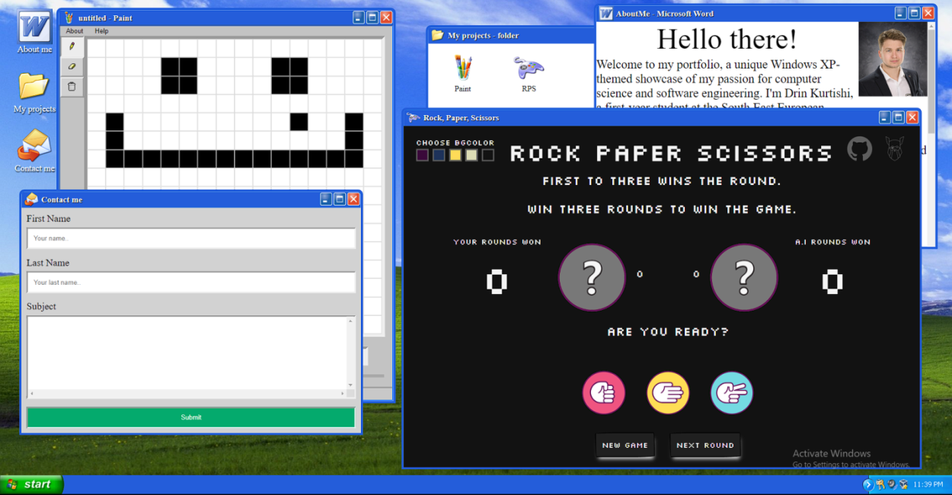The initial version of the template started with sketching the overall structure of the website. Each type of content (lock screen, about me, projects, contact) was visually represented to plan the layout and user interface. The final version of the template included a Windows XP-themed design, with attention to detail in replicating the interface elements of that era.

# 6. Website Diagram

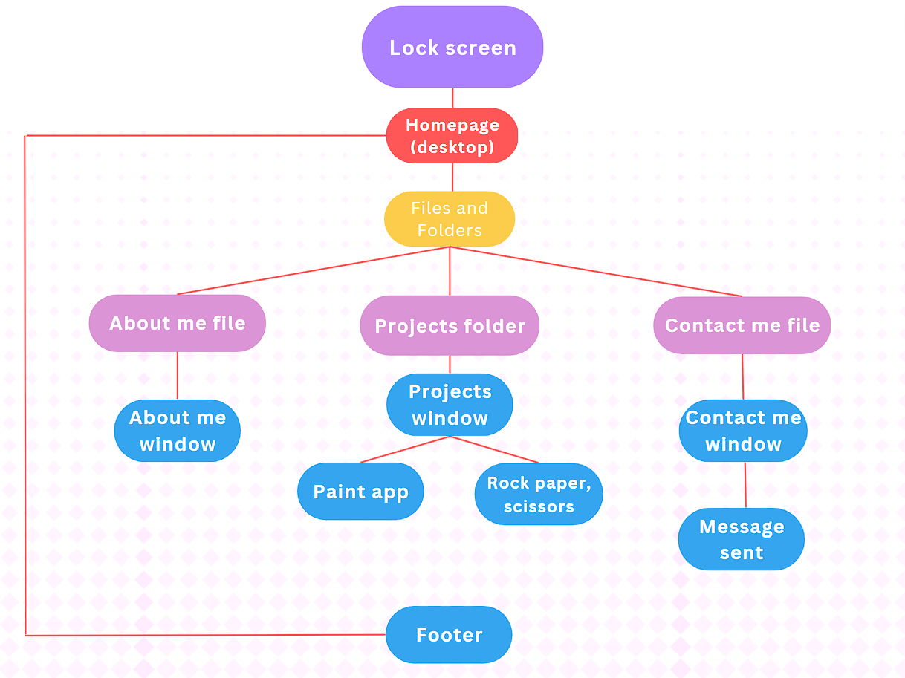The website diagram illustrates the overall structure of the website and the links between different sections.

# 7. Tools and Platforms

To create the vector and visual designs of the website, tools like Gimp were used, which allowed for precise and professional design creation. For website development, HTML5, CSS, and JavaScript were used to build the website. Visual Studio Code was utilized for coding and Google Chrome for testing.

# 8. Implementation

The implementation process of the portfolio website involved the following steps:

HTML Structure: The website's structure was defined using HTML. Each section of the website, such as the lock screen, about me, projects, and contact. The appropriate HTML tags and elements were used to organize the content and provide semantic meaning.

CSS Styling: CSS was used to apply styles and formatting to the HTML elements. The Windows XP theme was implemented by replicating the visual elements and color scheme of the operating system.

JavaScript Functionality: JavaScript was utilized to add interactivity and dynamic functionality to the website. For example, the lock screen includes a script that listens for a click on the username prompt and redirects the user to the homepage. Also making the windows draggable and manipulating their z-index to fully emulate a desktop experience.

Responsive Design: The website was designed to be responsive, meaning it adapts to different screen sizes and devices. In mobile view, the website is more basic where the files are already opened.

Deployment: Once the website was developed and thoroughly tested, it was deployed to a hosting platform called Github Pages to make it accessible on the internet.